IPL-Web

Final Project

Table of Contents

Project Proposal 3

Goals and Objectives 3

Project Scope 3

Project Specifications 3

Target Audience 3

Project Deliverables 4

Resource Requirements 4

Project Tasks and Milestones 4

Project Assumptions 5

Project Report 5

Detail Design 6

Home Page 6

Registration Page 6

Login Page 7

All Comments Admin View 7

All Matches Admin View 8

All Matches Visitor View 8

All Team Visitor View 9

Match Centre  Visitor View 9

Project Testing 10

User Manual 10

Summary 10

System Configuration 10

User Access Levels 10

# 

# Project Proposal

## Goals and Objectives

The main goal or aim of the project is to implement an online web application named “IPLWeb”. The main purpose of the application is help people to find IPL match schedule, team details and power for registered user to share their point of view in a collaborative manner. In this application there are two types of users- admin and registered visitor. Admin has different functionalities as compare to registered visitor. Admin can add, edit, delete and check details of all teams and their logo, all seasons, and matches. Admin can delete and check details of the comment and authority to remove inappropriate comment.

## Project Scope

The scope of this project is to implement an app named “IPLWeb” with the help of which user can find any team details as well as match information and authority to share their point of view. The duration of the project is 20 working days which is equals to 4 weeks.

## Project Specifications

* Admin login/logout
* Add, edit, delete, and check details of team by admin.
* Admin can delete, edit, and check season details.
* Admin can delete and check match details.
* Admin can register new admins.
* Registered Visitor can login/logout.
* New Visitor can register.
* Registered Visitor can share its point of view.

## Target Audience

The target audience for this project is the people who love cricket as well as remains up to date regarding match details. The age can go from 5 plus to 100 plus.

## Project Deliverables

The deliverables of the project are:

|  |  |
| --- | --- |
| **Deliverable** | **Description** |
| Final Report | This will be the final report of the project. |
| Coding | The executable code of the project will go under this. |
| Documentation | This portrays the documentation of the project. |
| Testing | All the test details will be covered in this part. |

## Resource Requirements

* Windows Operating System.
* Microsoft word for documentation.
* Asp.net MVC Framework
* 64-bit Processor and 4 GB or more RAM
* Identity framework- ASP

## Project Tasks and Milestones

|  |  |  |  |  |
| --- | --- | --- | --- | --- |
| **Tasks** | **Week-1** | **Week-2** | **Week-3** | **Week-4** |
| Brainstorming and analysis |  |  |  |  |
| Planning and initial meeting Project Proposal document. |  |  |  |  |
| Database Design and UI Design |  |  |  |  |
| Identity framework implementation |  |  |  |  |
| Coding for admin and reporter |  |  |  |  |
| Testing |  |  |  |  |
| Final Documentation and closing |  |  |  |  |

## Project Assumptions

Following are the assumption made while implementing the project:

* One admin and registered visitor will be registered by default.
* Application will be free and open source.

# Project Report

#### Functional and Non-Functional

|  |  |
| --- | --- |
| Users | Functional |
| Admin | * Login/logout * Register new admins. * Admin can add, edit, delete, check details for teams. * Admin can edit, delete, and check details for season details. * Admin can delete and check details for the match. |
| Customer | * Can view details of teams and their matches. * Can share their point of view regarding a match. * New customers can register for free. * Login using valid credentials |
|  | Non- Functional |
|  | * High speed * Fast Loading time * High performance and security * All browsers compatibility. |

## Detail Design

### Home Page

The main landing page of the application. On navigation bar options are- Home, All Matches, All Teams, Register, Login.

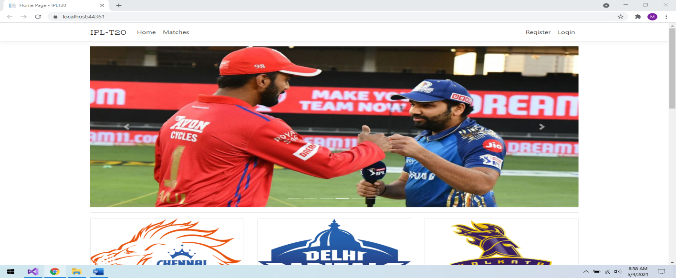

### 

### Registration Page

With the help of this page, new registered visitor can sign up for the app

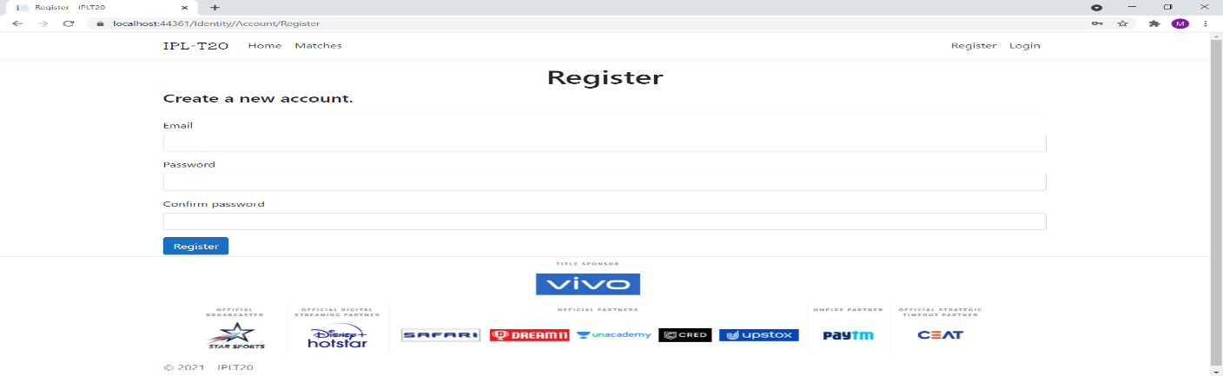

### 

### Login Page

With the help of this page, registered visitor and admin can login to the application using their valid credentials.

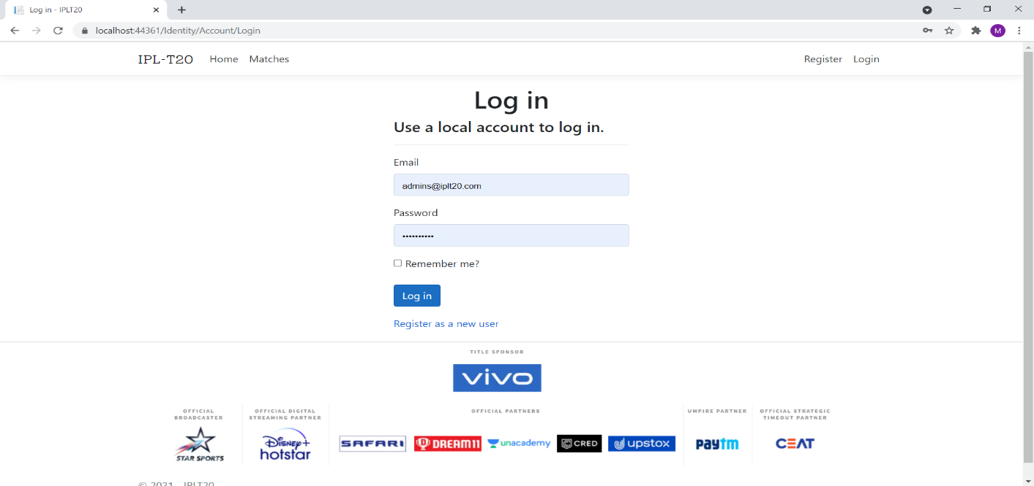

### 

### All Comments Admin View

This page highlights all the comments available on the application. Admin can delete and check details of the existing ones.

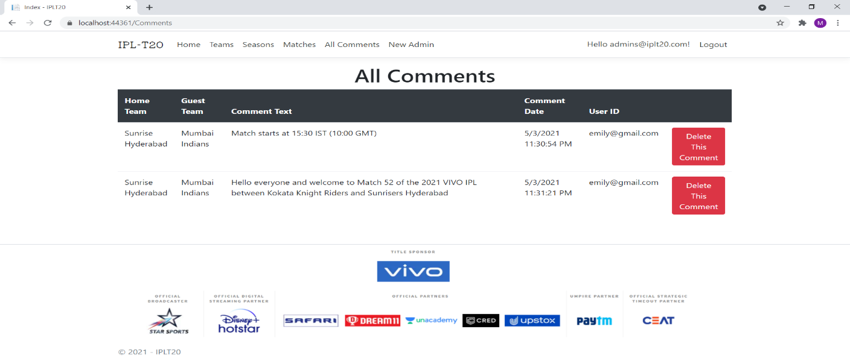

### All Matches Admin View

With the help of this page admin can manage the match details by editing, deleting and checking their details.

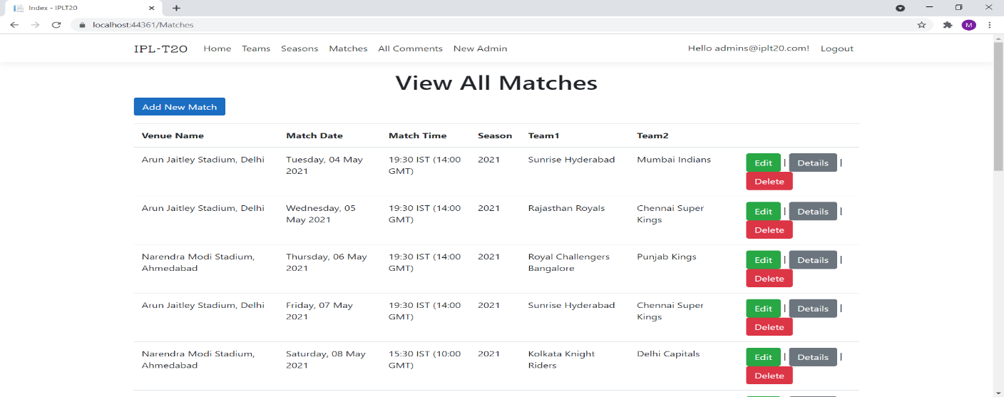

### 

### All Matches Visitor View

With the help of this page Visitor can view All Match details.

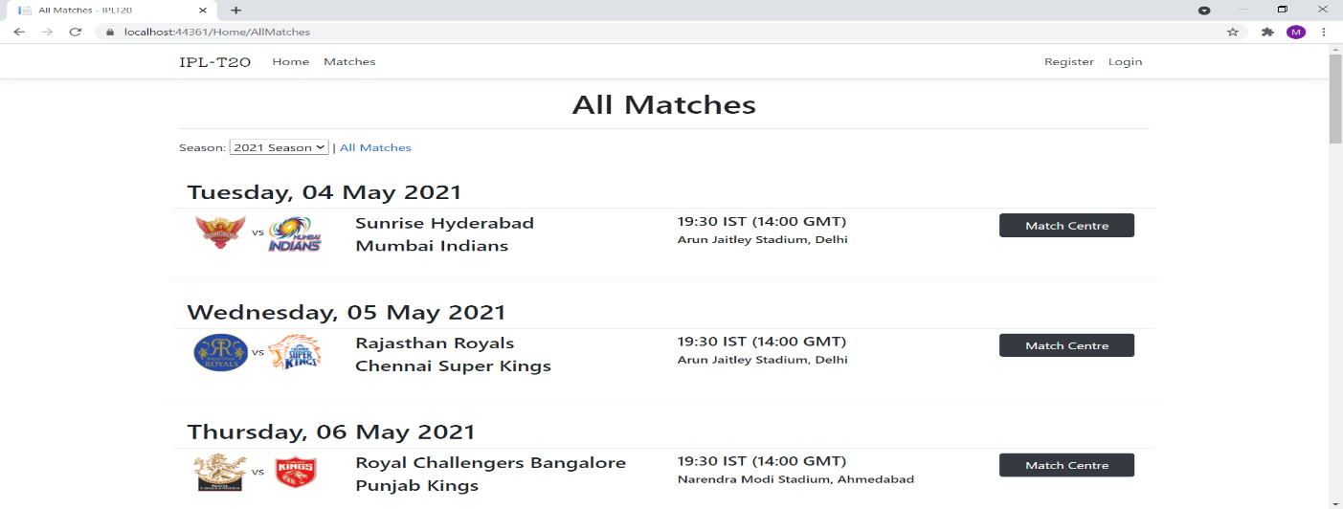

### 

### All Team Visitor View

With the help of this page visitor can check the details of the Team and link to their matches.

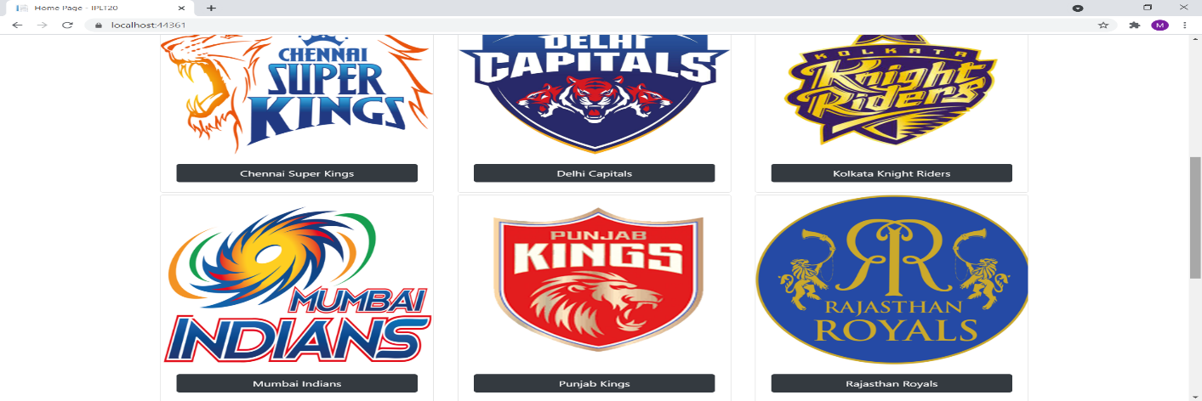

### 

### Match Centre Page Customer View

This page shows the Match Centre of a particular match and its related comments.

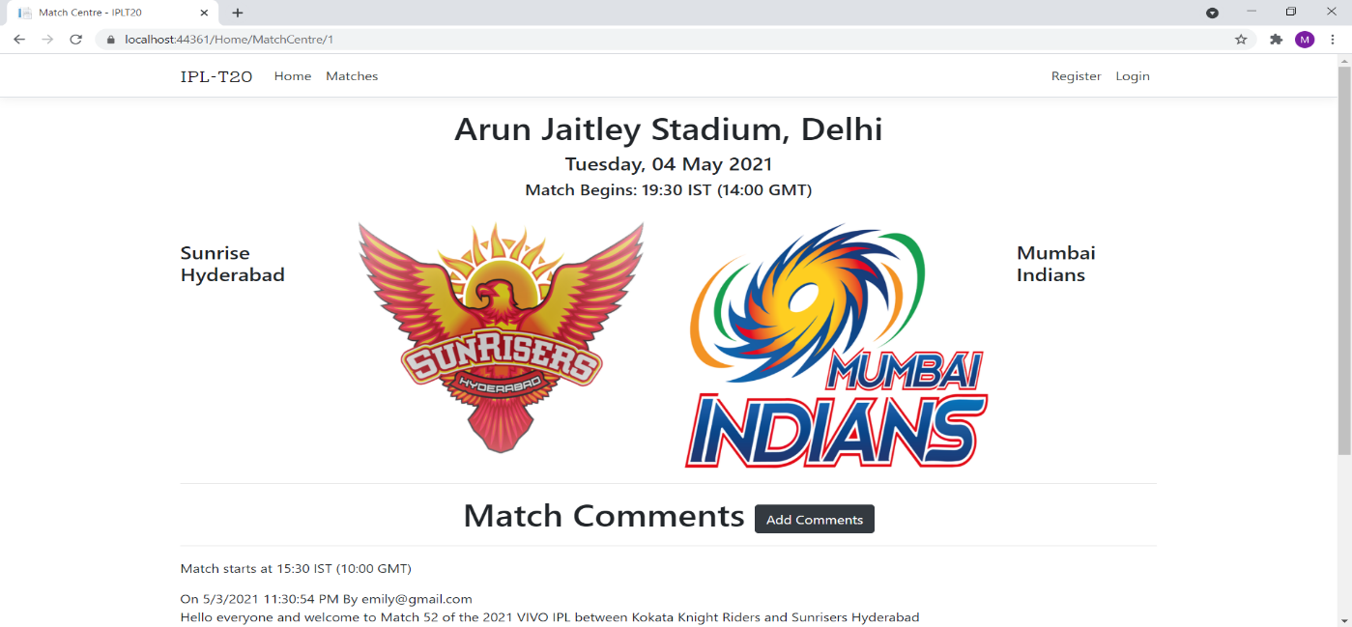

## 

## Project Testing

The testing file for usability testing is attached as [usability test.xlsx](usability%20test.xlsx)

# User Manual

The main purpose of the application IPLWeb is to help people to find team details and their match details as well as authorize them to share their point of view. In this application there are two types of users- admin and registered user or visitor customer. Admin has different functionalities as compare to customers. Admin can add, edit, delete, and check details of team, season, and match entries. Also, admin can delete the inappropriate point of view share by registered user.

## Summary

### System Configuration

This app will be useful to for distributing mobile information in presentable format.

### User Access Levels

Only registered users can access the features of this application.

* **Registered Visitor:** New visitor can register and existing can login using their own credentials. They have limited access.
* **Admin:** Admin has full access of the app can register new admins.